Minutes
Island County 2% Committee

June 4, 2020
Zoom, due to COVID-19

Guest presentation was provided from Jordan with Dean Runyon on the latest report.

The meeting was called to order at 11:43am by Vice-Chairman Chet Ross.

Quorum: x=members present
Tim Callison X | Com. Jill Johnson | Pat Powell
Debra Bell X | Gregg Lanza X | Mitch Richards X
Dianne Binder X | Joanne Lechner X | Tom Felvey
Stephane Cook | Jessica McCready X | Chet Ross X
Miranda Hoppock | Inge Morascini X | Sharon Sappington, EDC X
Lynda Eccles X | Robyn Myers X | Erica Wasinger

In addition to the above members also in attendance this meeting were: Sherrye Wyatt, Whidbey Camano Islands Tourism Coordinator, Jack Penland, Computer PIX LLC, Scott Rosenkranz, Rosenkranz Productions, Laura Hilton, Is Co. Tourism Contractor; Erin Osborne, Osborn Northwest Public Communications.

GUESTS: Jordan Bohlander, Dean Runyon.

Adoption of the Agenda: Joanne motioned, and Lynda seconded the motion to approve the agenda. Motion approved unanimously via voice and visual hand raising.

Minutes from the March meeting were presented. Deb motioned and Lynda seconded the minutes be approved as presented. Motion approved unanimously via voice and visual hand raising.

Treasurer’s report was presented by Dianne Binder. Invoices were paid at the Management Committee on May 26, 2020.

Old Business

- None

New Business

- Recovery plan review and Sherrye’s PR report given by Sherrye and the team involved in the recovery plan reported.
- Chamber Roundtables: all communities reported.

Monthly PR media Report

Sherrye Wyatt Writing & Public Relations

- Members of the Tourism Committee have been sent the revised marketing plan and new 2019 Dean Runyon report. Both will be reviewed on the June 4 phone call at 11 a.m.
- We’re actively involved with the Island County Economic Recovery Task Force which resulted in the county safety messaging Gail the Whale which we encourage everyone to use. https://whidbeycamanoislands.com/gail-the-whale-downloads/
- We will have access to Buxton research purchased by Island County, with a meeting planned this month to discuss in more depth and learn how to use it.
- Washington Tourism Alliance (WTA) has purchased 2019 state and countywide research which we’ll be reporting on later this month. This replaces the state’s purchase of Dean Runyon, which we did independently.
- Sherrye’s been participating in several weekly calls including the Northwest PR Council created by WTA and WSDMO.
- The Port of Seattle international offices are releasing a press story to highlight our “Escape it All” videos in the UK, Australia and German marketing. In addition they are offering a Dropbox file so their overseas office staff may download additional photos which we provided. Attached is the release from the UK office and the distribution list.
- Sherrye’s been communicating with Jill Andrews at Certified Folder about the current and future distribution of our map. We will be credited for months where our map was pulled from certain locations. When future distribution will start up again in some locations, like Washington State Ferries, is unknown.

Osborne Northwest Public Relations

Project Management
- Developed the PR themes, strategies and angles to support the mot up to date recovery plan.
- Developed strategy and draft press release to communicate and create awareness for Gail the Gray Whale and support safe practices as travel begins to reopen; the news is slated to go out the first week of June.
- Maintained communication with the following upcoming media visits, to adjust travel and editorial plans. We are monitoring the health climate, travel restrictions regarding these visits. Dates may be rescheduled as needed as the dates near.
  - Sara Franklin, Travel + Leisure, POSTPONED, Fall 2020, had been researching a story for the Sept. 2020 issue’ this has been postponed until further notice.
  - Michelle Williams, Rockin Red Blog, monitoring a potential reschedule for original dates of June 3-6, Michelle has been named among the top 15 most influential people in wine; she is a contributor to Daily Meal and Forbes (as recently profiled in Wine Industry Advisor)
  - Barb Webb, Second Season Travel (a lifestyle brand written for 50+ that’s syndicated by Daily Meal, a major national brand); October 17-19; plans to visit Seattle/Tacoma/Whidbey on a Pacific NW agritourism and food-focused itinerary to share with readers in a destination feature.

Pending Press
- Travel Channel (online); plans to include Whidbey and Camano Islands in a roundup of virtual travel experiences to take from home; timing June 2020.

Press Highlights include nine pieces of coverage with an estimated 9.79 million impressions. To view the coverage book report in full for the month, go here.
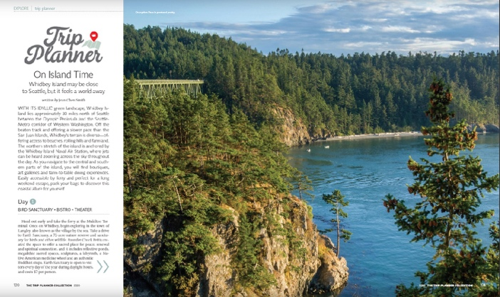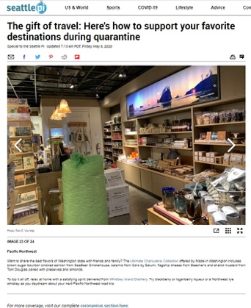

ComputerPix

Digital Marketing Report May 2020

Summary
- Website traffic is rebounding and within shouting distance of 2019 levels.
- Traffic and searches reflect a desire for outdoor space and activies
- The site now reflects the “Escape It All Slogan”
- We are continuing the “Escape It All” page designed to keep us top of mind without suggesting that people actually travel here.
- A special “Covid-19” front page section is slowly shifting to a summary of what’s open

Website Shows Interest in Travel Here Remains High

Destination Analysts have been reporting survey results for the past few weeks that shows an increased positive attitude towards traveling. But, that’s on a nationwide basis, what does the data tell us about here?

Keep in mind that interest in travel grows as the weather warms up.

That’s only logical. But, the month-to-month increase this year is unusually high, driven by a very locked-down April and the gradual opening of the state in May

 | May | April | Month to Month  Percent Change
2020 | 19,617 | 14,158 | 38.6%
2019 | 22,876 | 23,829 | -4%
2018 | 21,299 | 20,467 | 4.1%

But, how does this year stack up against previous years? This table shows that things were really starting to take off (60.1% increase in February) and then the coronavirus hit. But, notice that in May the drop is much less than March or April, down 14.3%.

 | January | February | March | April | May
2020 | 15,931 (.1%) | 24,332 (60.1%) | 14,521 (-27.8%) | 14,158 (-40.1%) | 19,617 (-14.25)
2019 | 15,915 | 15,156 | 20,111 | 23,839 | 22,876
2018 | 11,786 | 12,655 | 18,904 | 20,467 | 21,299

During this most recent week, May 24 to May 30, the number of 2020 users are down only 4.8% from 2019.

What are the most popular pages? Over the past 30 days, they’re as follows:

 | Page | Views | % of Pageviews
1. | Home | 6129 | 14%
2. | /jets-on-whidbey/ | 2385 | 5.5%
3. | /things-to-do/ | 2,126 | 4.9%
4. | /3-deception-pass-hikes-that-are-pure-magic/ | 1,965 | 4.5%
5. | /activities/parks-and-scenery/ | 1,506 | 3.5%
6. | /deception-pass-state-park/ | 1,357 | 3.1%
7. | /how-to-get-to-whidbey-island/ | 1,116 | 2.6%
8. | /restaurants/take-out-delivery/ | 1,040 | 2.4%
9. | /things-to-do/fishing-clamming-crabbing/ | 1,000 | 2.3%
10. | /bicycling-around-the-islands/ | 857 | 2%

What are people search for that got them to our site?

Search Query | Clicks | Impressions | CTR | Average Position
whidbey island | 1718 | 41733 | 4.12 | 2.47
deception pass hikes | 277 | 1123 | 24.67 | 2.74
deception pass | 263 | 37694 | 0.70 | 1.94
deception pass state park | 175 | 10790 | 1.62 | 3.56
double bluff beach | 133 | 1775 | 7.49 | 6.30
deception pass bridge | 132 | 4820 | 2.74 | 5.52
deception pass hike | 129 | 452 | 28.54 | 5.01
whidbey island washington | 127 | 2726 | 4.66 | 2.29
camano island | 122 | 12601 | 0.97 | 6.97
deception pass hiking | 112 | 374 | 29.95 | 1.78

Escape It All

Since the last formal report, the main theme of the website has shifted from “Drive off the Mainland” to “Escape It All.” The phrase started as our title for the page for our “virtual visit” to Whidbey and Camano islands, but it quickly became apparent that the phrase would be very useful in these times as our overall phrase.

Escape It All Page
The “Escape It All” page serves as a single-page virtual visit to Whidbey and Camano Islands. The page is our attempt to remain “top of mind” without suggesting to people that they violate bans on leisure travel. The videos are all branded under “Moments of Zen” meaning people should watch, enjoy, and “Escape it All” but actually visit later. Videos range from simply watching deer to profiles of some of the region’s photographers.

Covid-19 Section

Like most Destination Marketing website, the Whidbey and Camano tourism website put up information about the coronavirus on the website. A front-page button leads to a special overlay of information. This section was routinely updated at least once a day during the first few weeks of the pandemic. It detailed what was closed and what services were cut or eliminated. As the state has opened up, the content is shifting to what is open.

Adjournment

Meeting adjourned at 1:05PM.
Next regular meeting is July 2, location TBD, from 11am-1pm.
Meeting recorded by Robyn Myers, and reviewed for submission by Joanne Lechner, Alternate Secretary.

